**Golytly/PEG**

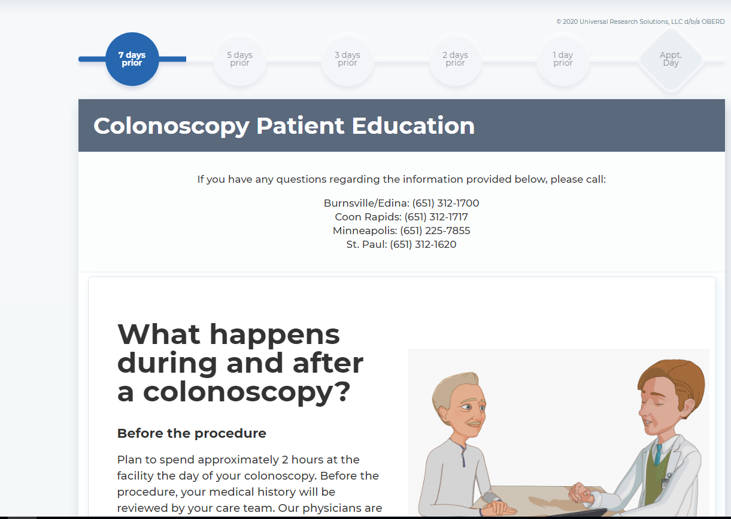

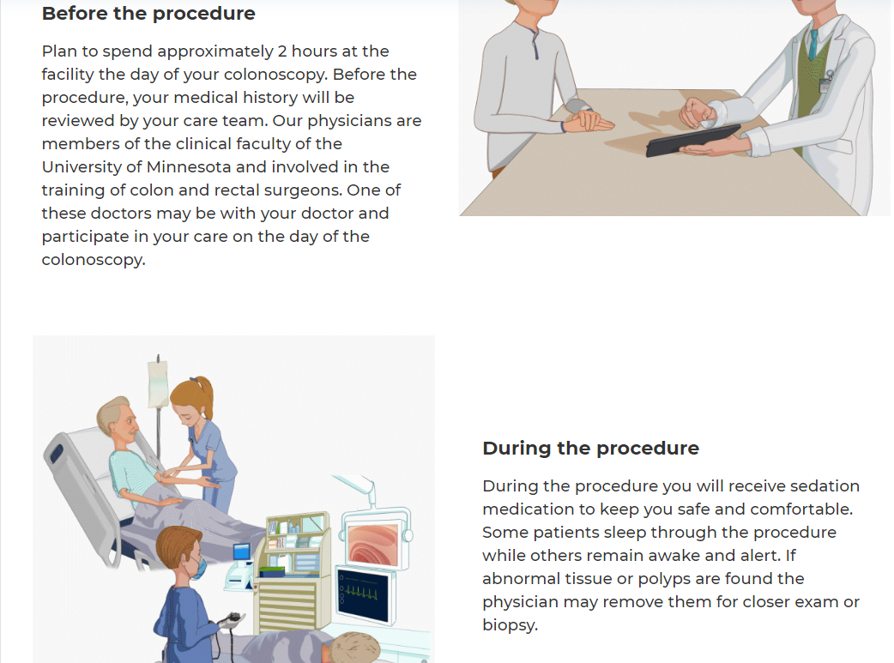

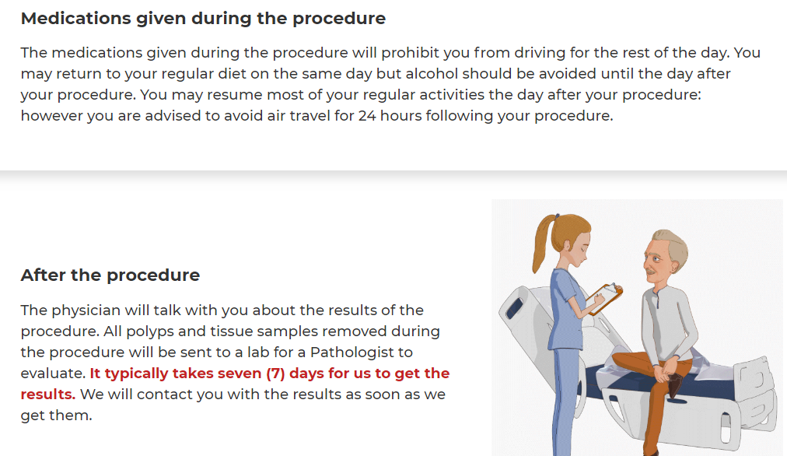

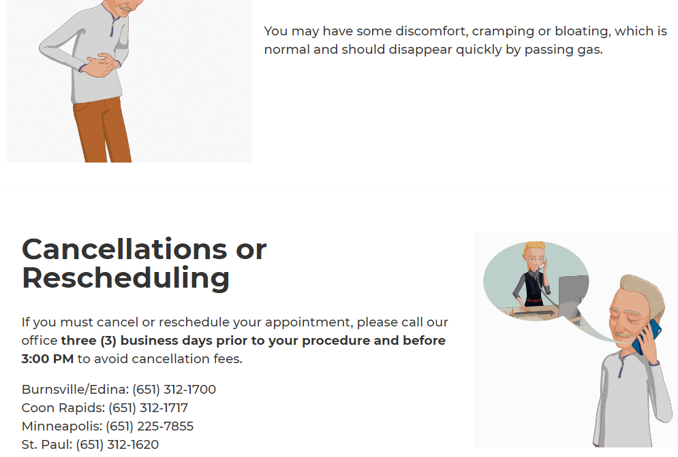

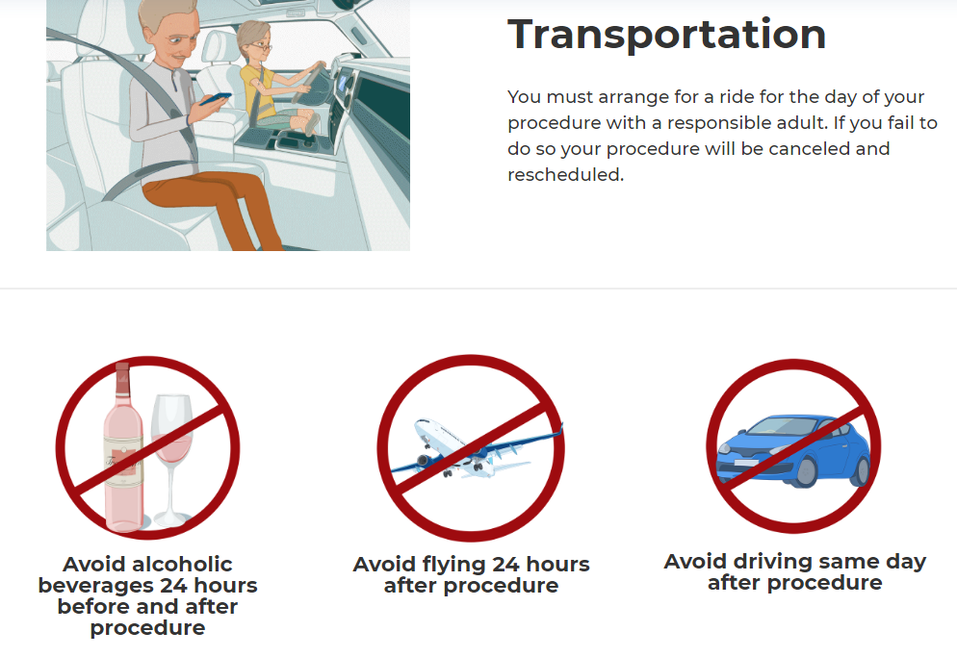

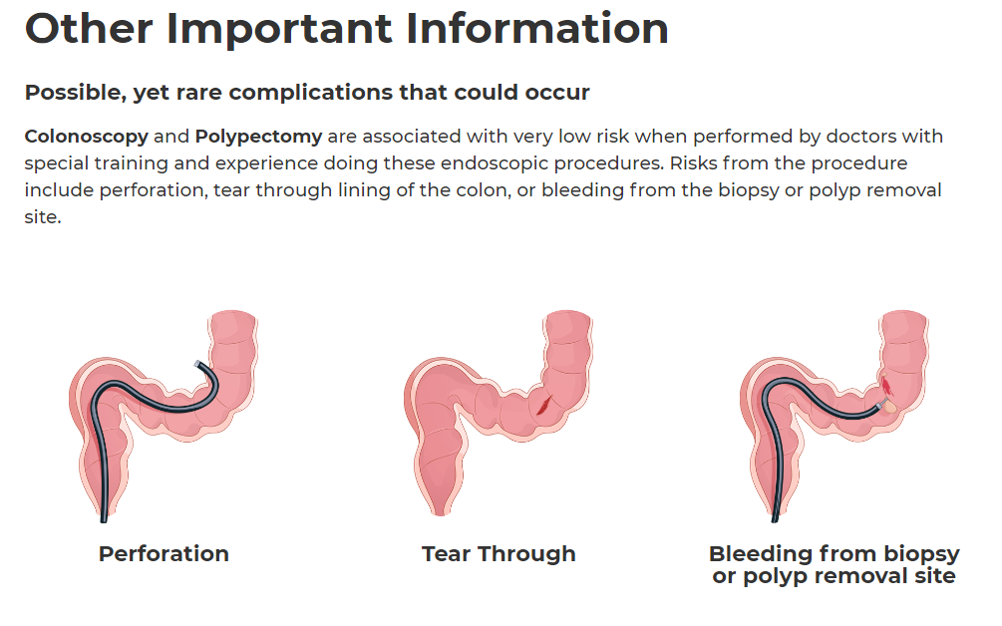

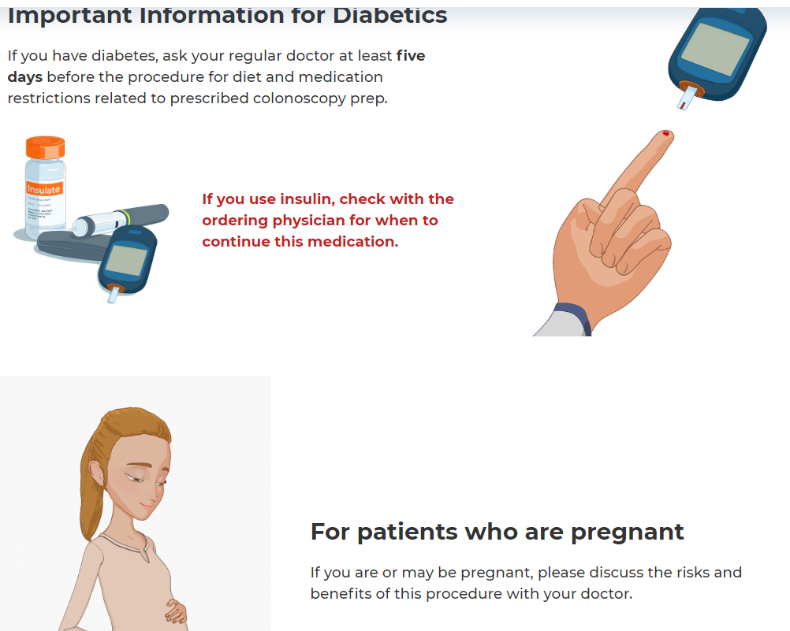

**MEDICATIONS TO STOP**

If you take the medications listed below you MUST stop taking it seven (7) day prior to your procedure. If it is not stopped there is potential for it to cause complications with anesthesia and your procedure may be canceled.

Stop taking the following:

* Phentermine
* GLP-1 agonists
  + - Dulaglutide (Trulicity®).
    - Exenatide (Byetta®).
    - Exenatide extended release (Bydureon®).
    - Liraglutide (Victoza®).
    - Lixisenatide (Adlyxin®).
    - Semaglutide injection (Ozempic®) (Wegovy).
    - Semaglutide tablets (Rybelsus®)(Wegovy).

**Once weekly injections:**

Patients are required to hold their GLP-1 agonist medication for seven days prior to their scheduled surgery.

**Daily injections:**

Patients are required to hold their GLP-1 agonist medication for one day prior to their scheduled surgery.

YOUR PROCEDURE MAY BE CANCELED, or the availability and type of sedation may change upon arrival for your procedure if you do not do so.

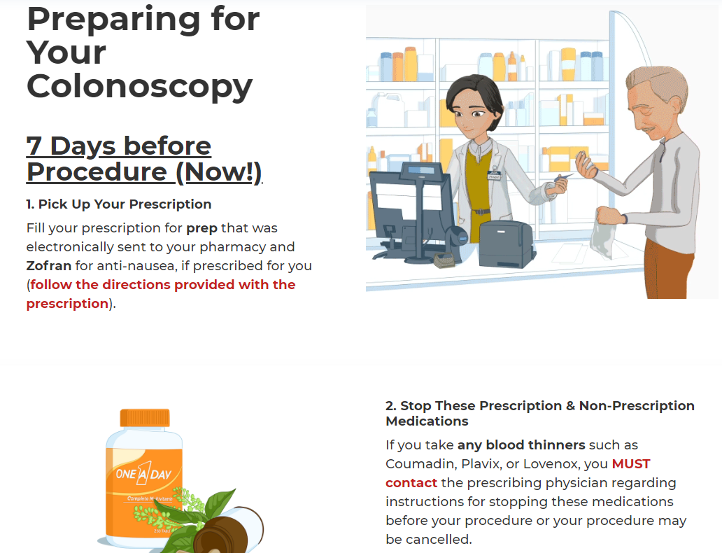

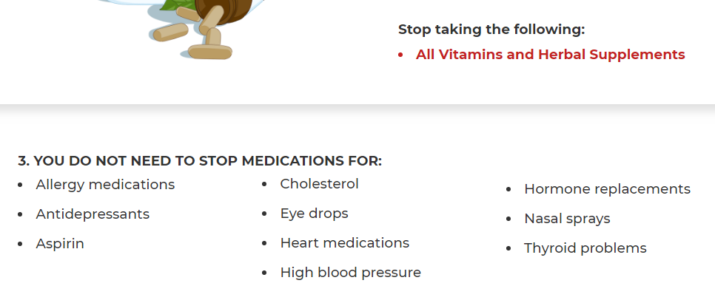

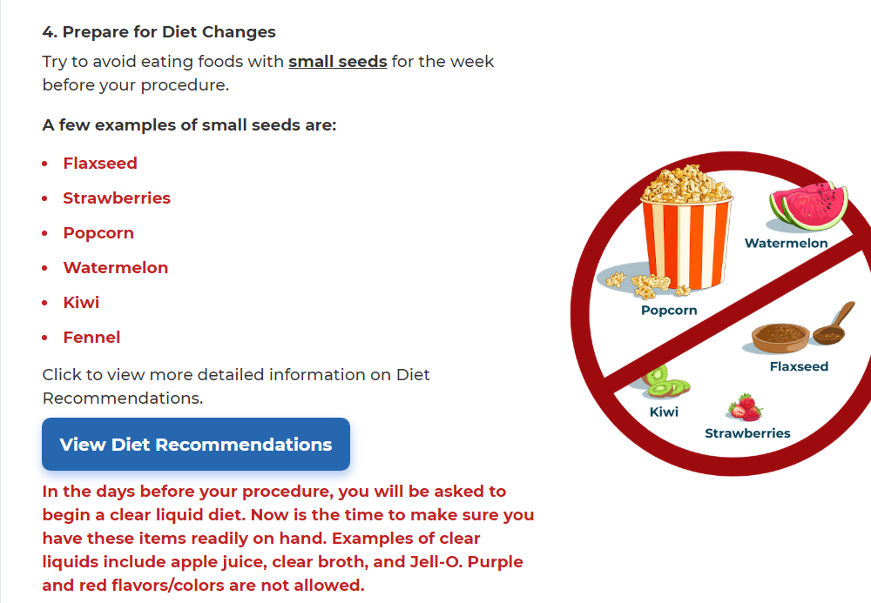

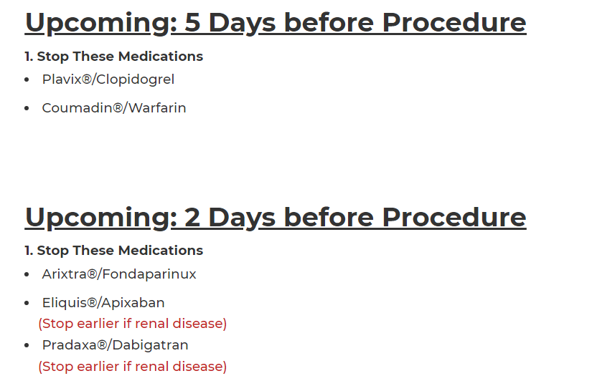

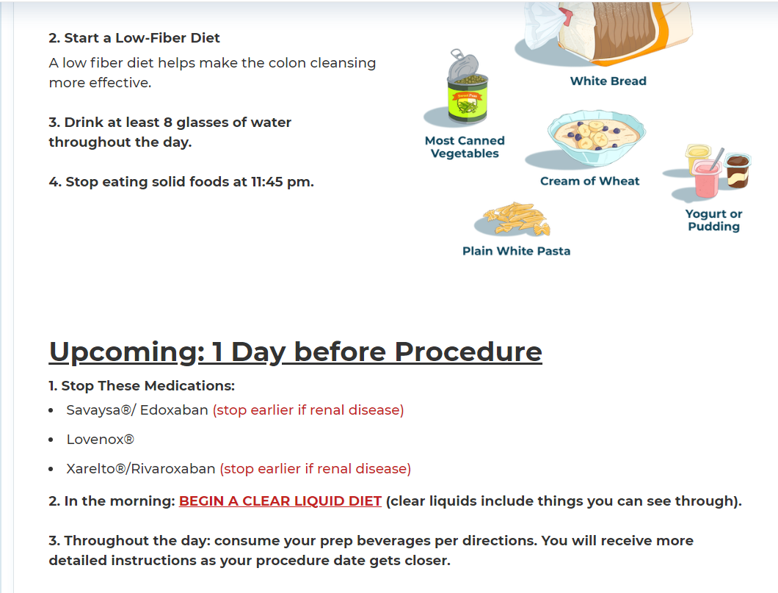

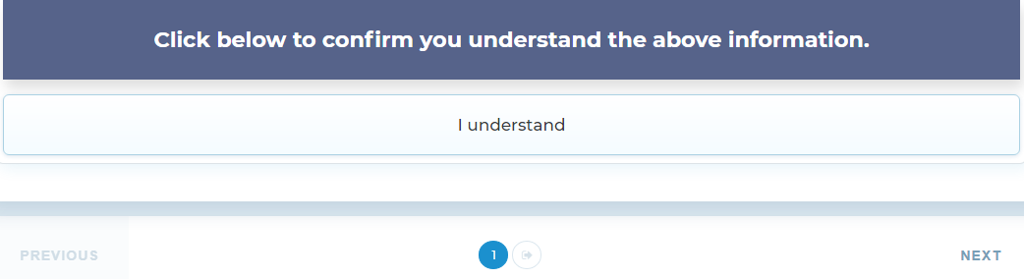

**Golytley/PEG 5 days prior**

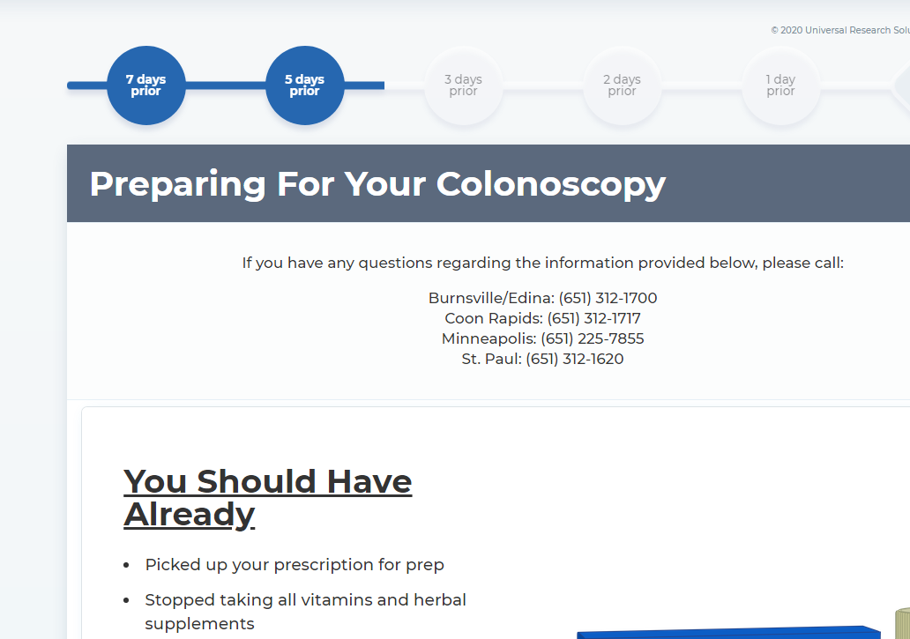

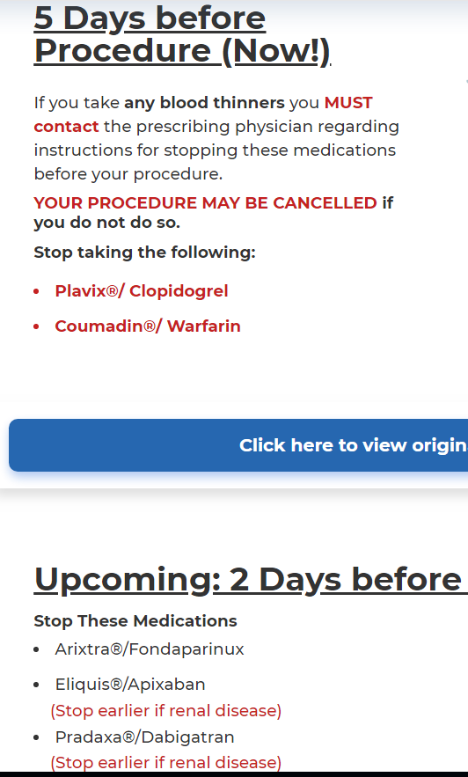

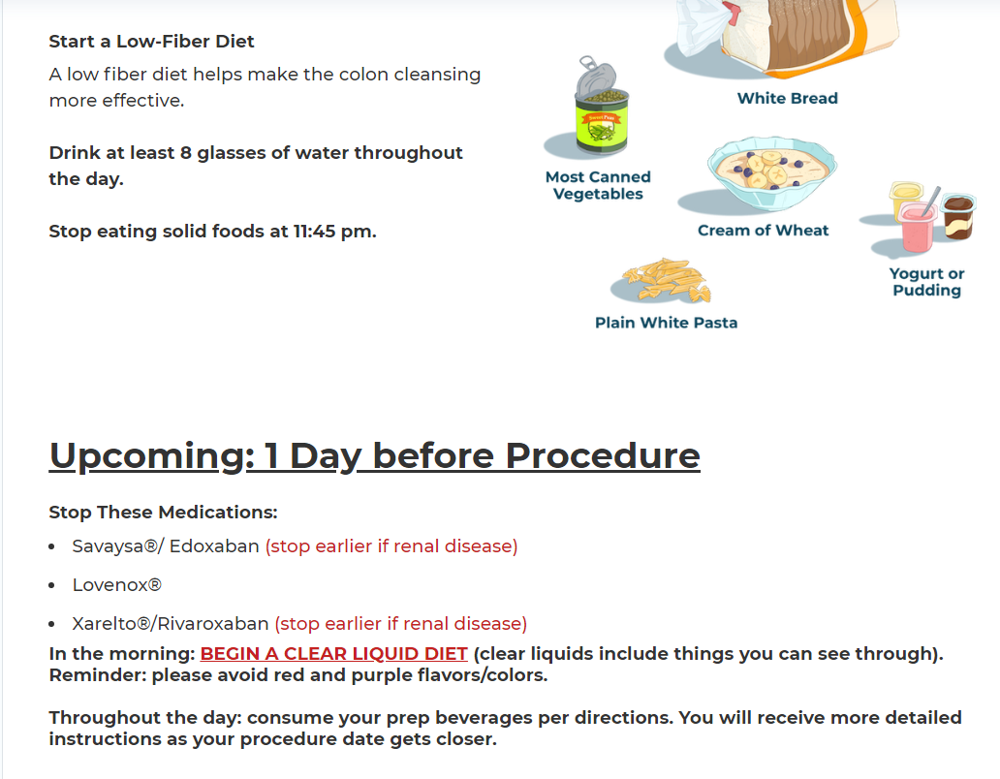

**Golytely 3 days prior**

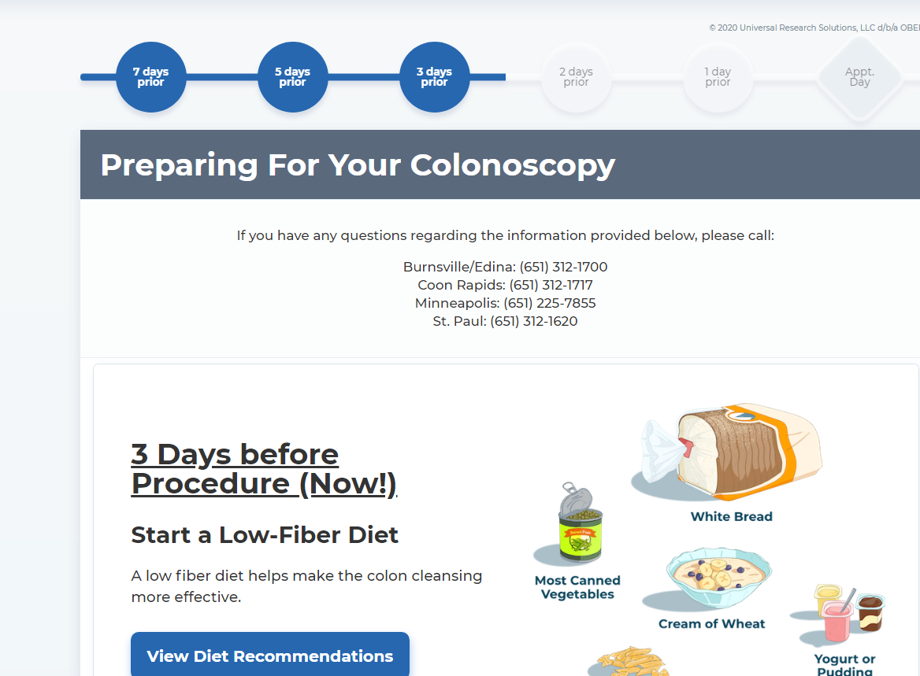

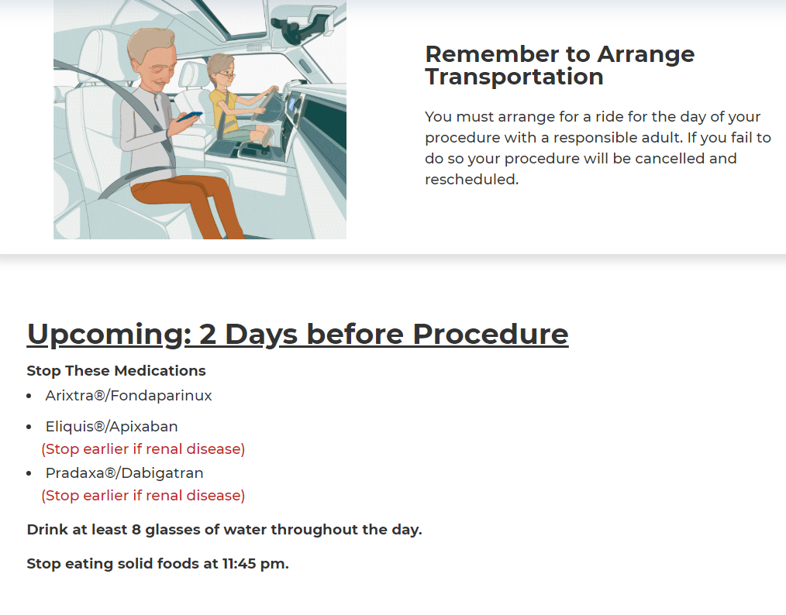

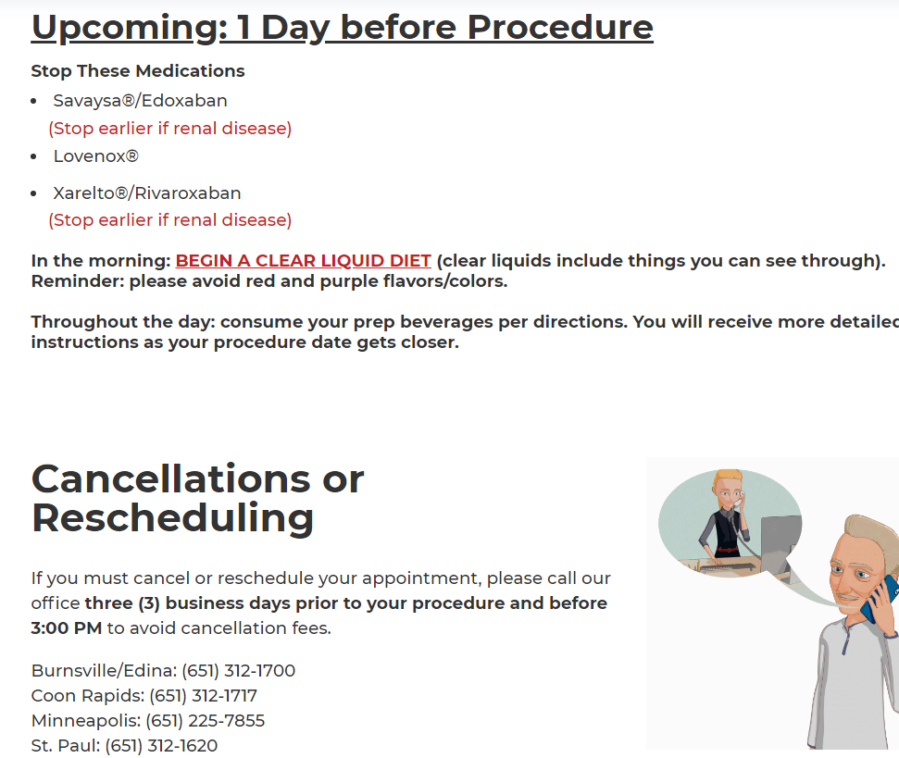

**Golytely 2 days prior:**

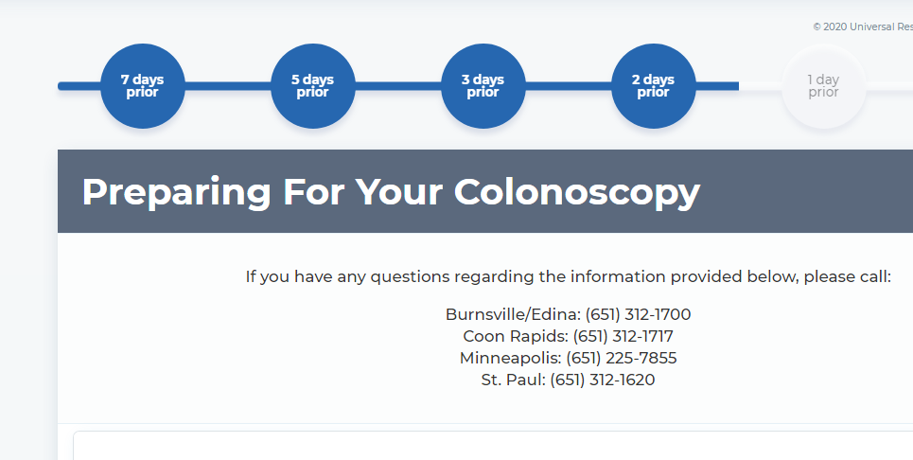

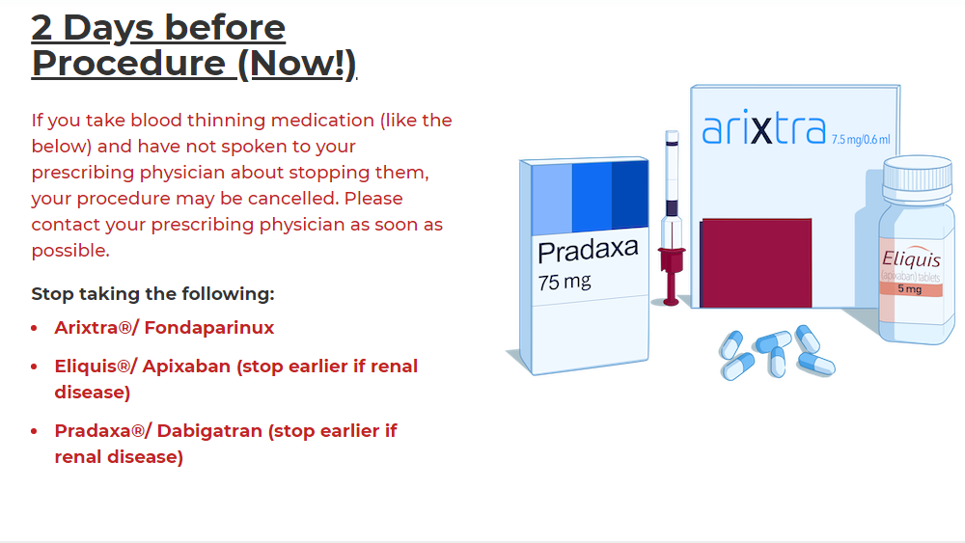

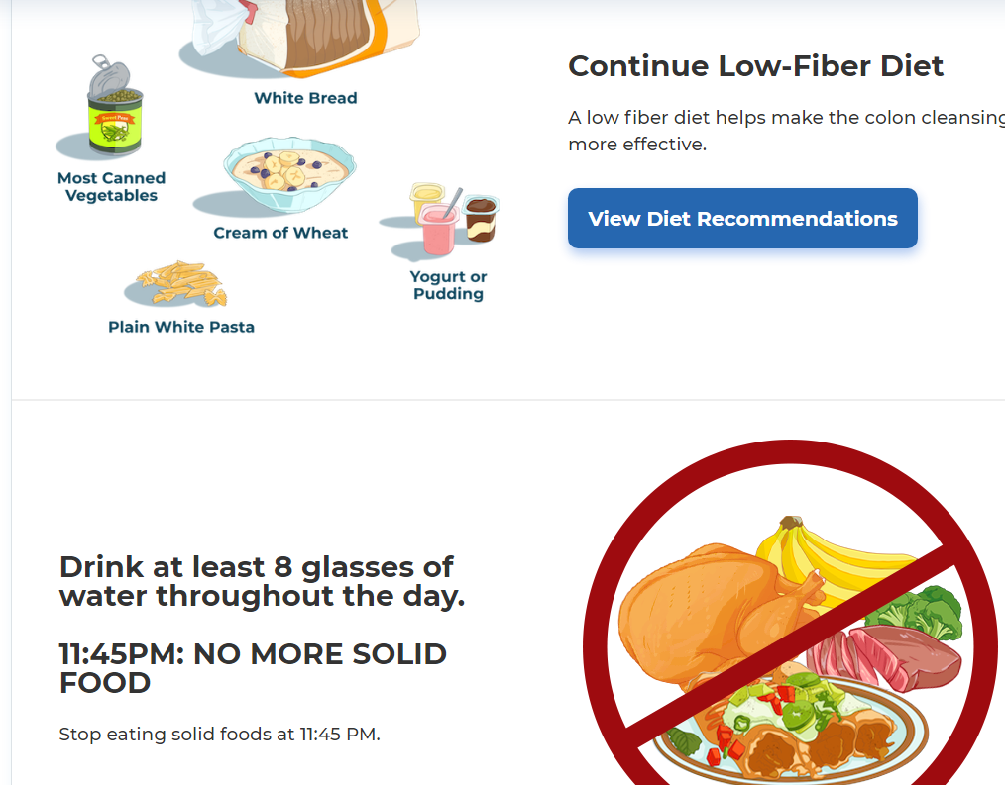

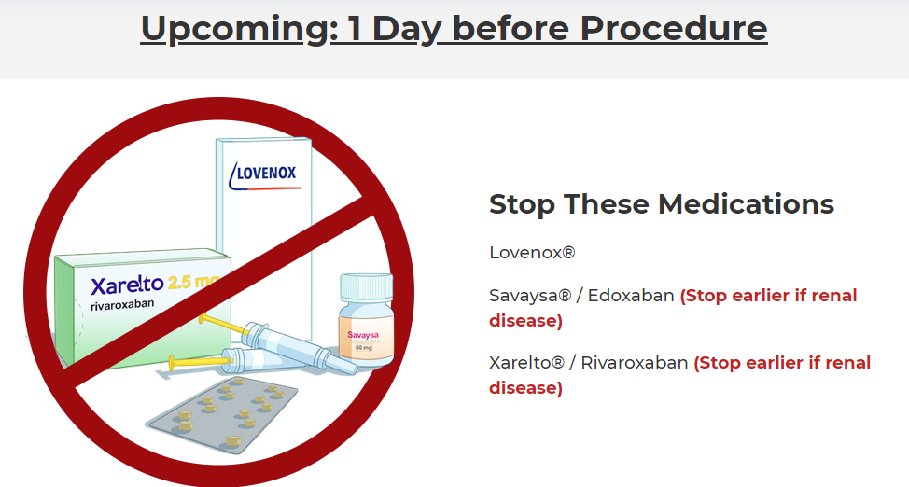

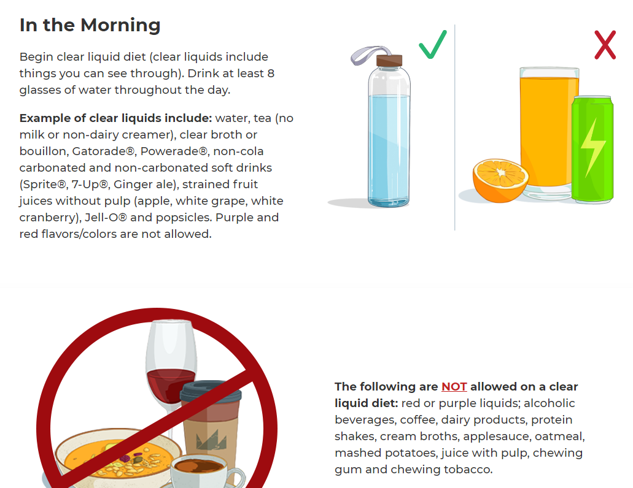

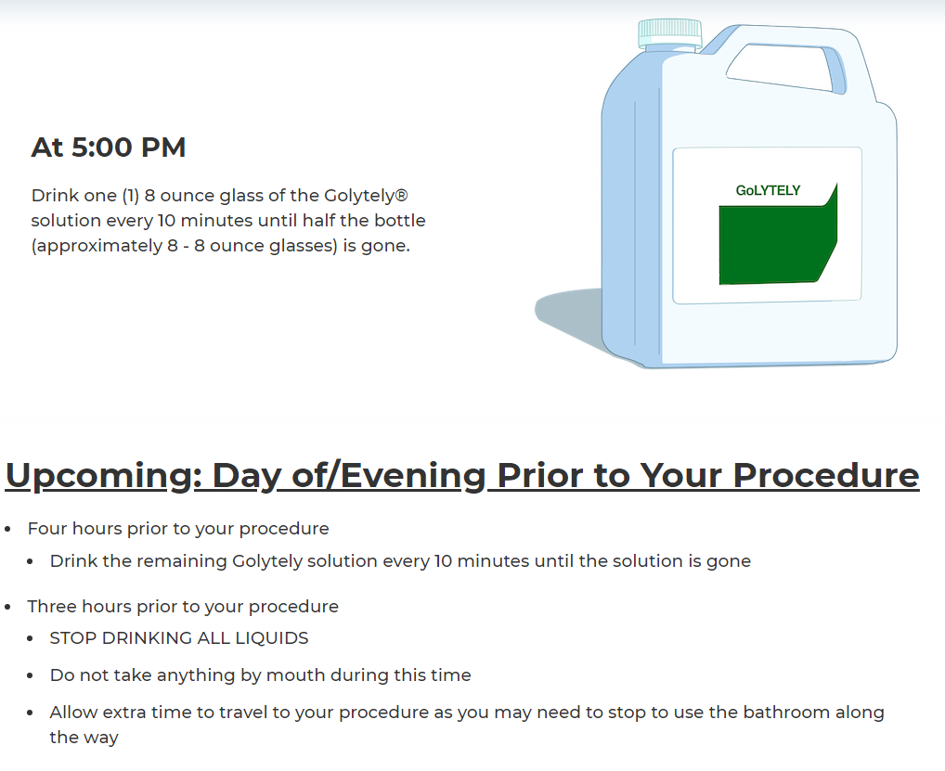

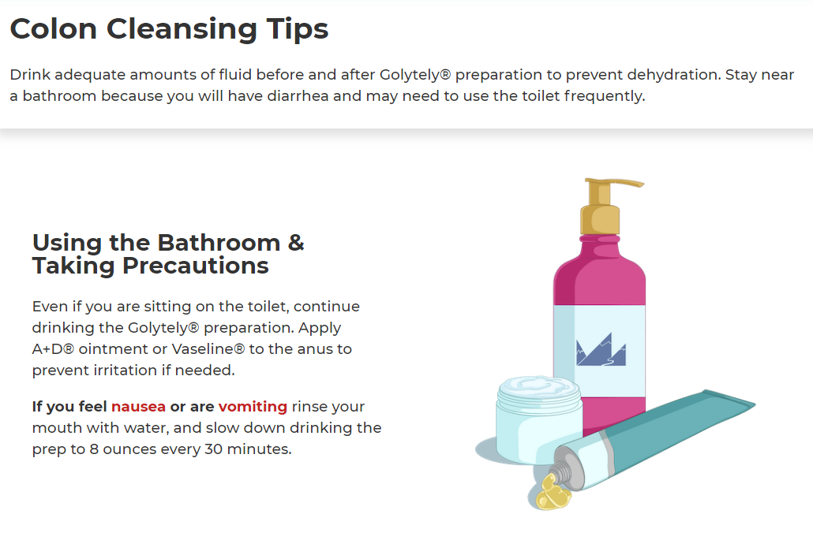

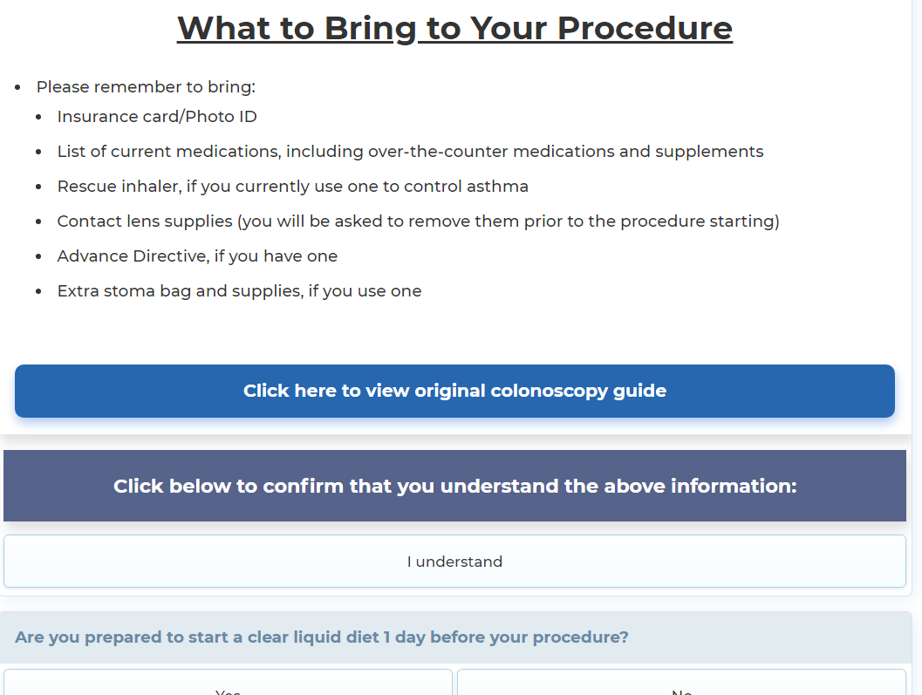

**Golytely 1 day prior**

